|  |  |  |  |  |  |  |  |  |  |  |  |  |  |  |  |
| --- | --- | --- | --- | --- | --- | --- | --- | --- | --- | --- | --- | --- | --- | --- | --- |
| |  |  |  |  | | --- | --- | --- | --- | | **System Analysis 1 Project** | | | | | **Rules** | 1) Grades:   * Class Diagram (***3 points***) * Activity Diagram (***3 points***) * Sequence Diagram (***3 points***) * Front End (***5 points***) * Data Flow Diagram (***2 points***) * Use Case Diagram (***2 points***) * We are going to ask each member a question. (***2 points***) 2) You must attend the project discussion on time, because if you came one minute late you **will lose 5 points**. 3) You don’t have to print the diagrams; you can explain everything on your laptop.   4) DON’T FORGET TO PRINT THE COVER SHEET BEFORE THE DISCUSSION AND FILL YOU NAME AND ID. | | | | **Team Members** | **Name** | **ID** | **Grade** | | **نورهان فريد عبد المقصود ربيع**  نسرين حسين محمد علي  امنية امير فاروق عبد الحميد  يارا مصطفي محمد عبد الغني  سيف احمد عبد العليم احمد  يوسف وحيد عبد الحميد فرحات | **202001012**  202000997  202000152  202001051  20180277  202001115 |  | |

**Analysis and Design of Information Systems –1**

**(IS 351)**

**Project description:**

The application aims to help doctors to enter/register as well as view a patient’s history (along with other patients’ details).

The application allows the doctor to:

insert various data fields regarding a patient; including the patient's name, age, gender, address, ID, medical conditions & diseases, medical history & allergies, medication provided and their doses, date of arrival, cost, etc. The doctor may now view this data and check any details whenever needed. The application allows the doctor to search for a patient by his/her name.

***System function requirements***

1. **Register:** the application allows the patient to make a registration for his first time AND allows the admin to register the doctor to the system
2. **Login:** the login allows the user to access to his data by entering the e-mail and password
3. **Daily patients list appointment:** it involves a list of patients attending a specific day to the doctor in addition to their data and the time interval
4. **Edit appointment:** the application allows an access to the doctor to edit the patient appointment.
5. **Edit patient profile:** the doctor got the access to edit the patient’s profile and their details.
6. **Searching by name:** the doctor could search on a specific patient by entering the patient’s name.
7. **Insert patient:** the doctor has the access to insert a new patient by entering the patient’s data
8. **Determine next consult:** the doctor has the access on the application to determine the next consult for the patient.
9. **write instruction of prescription:** the doctor could write the instructions of the prescription for the patient on the application which make it easier for both.
10. **print prescription:** the doctor could print the prescription from the application.
11. **View list of diseases:** the application got the access of showing list of diseases for the doctor.
12. **Doctor’s profile:** the application shows the doctor’s profile which contain name, age, gender, clinic address, phone number and rate which will be available to be observed by both doctor and patient.
13. **Patient profile:** the application shows the patient’s profile which contain his details: (name, age, gender, phone number, address, ID, medical history, medical conditions, medication provided and their doses, date of arrival).
14. **Rating doctor**: the patient has ability to rate the whole doctor after finishing the treatment.

**1-Usecase Diagram:**

**2-Activity Diagram:**

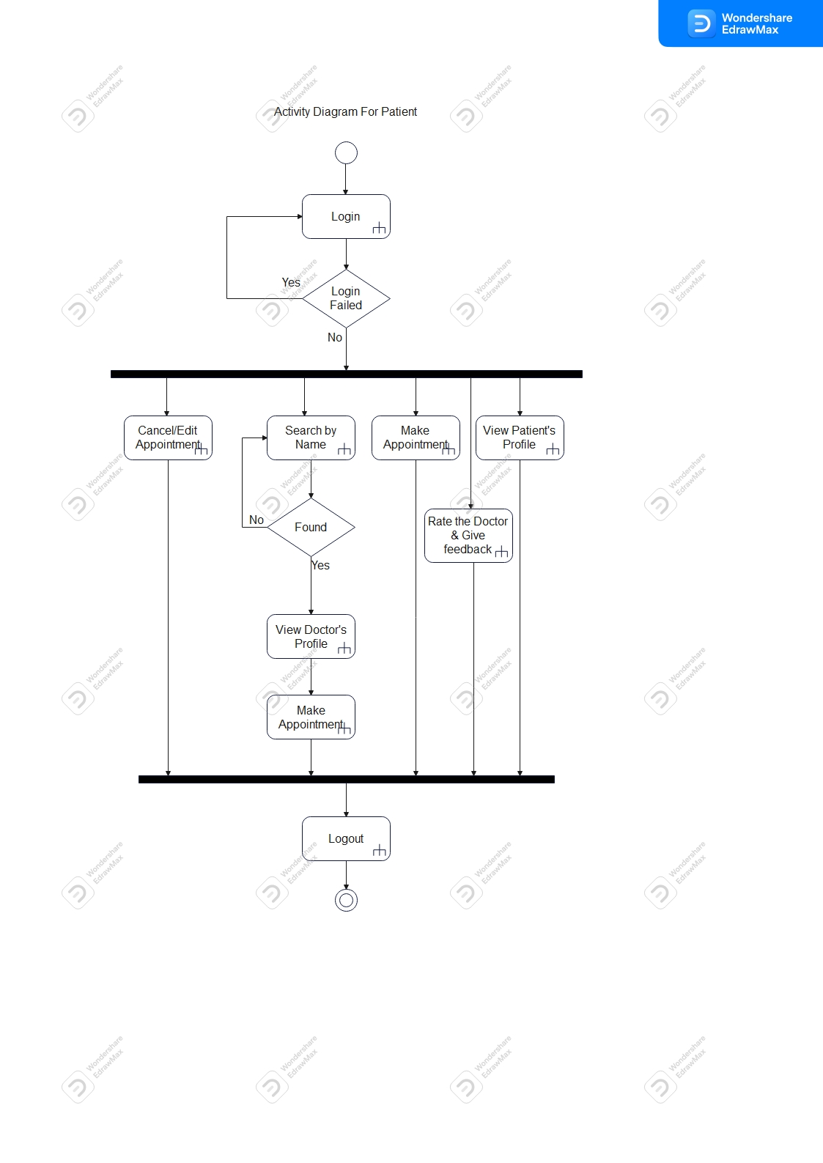

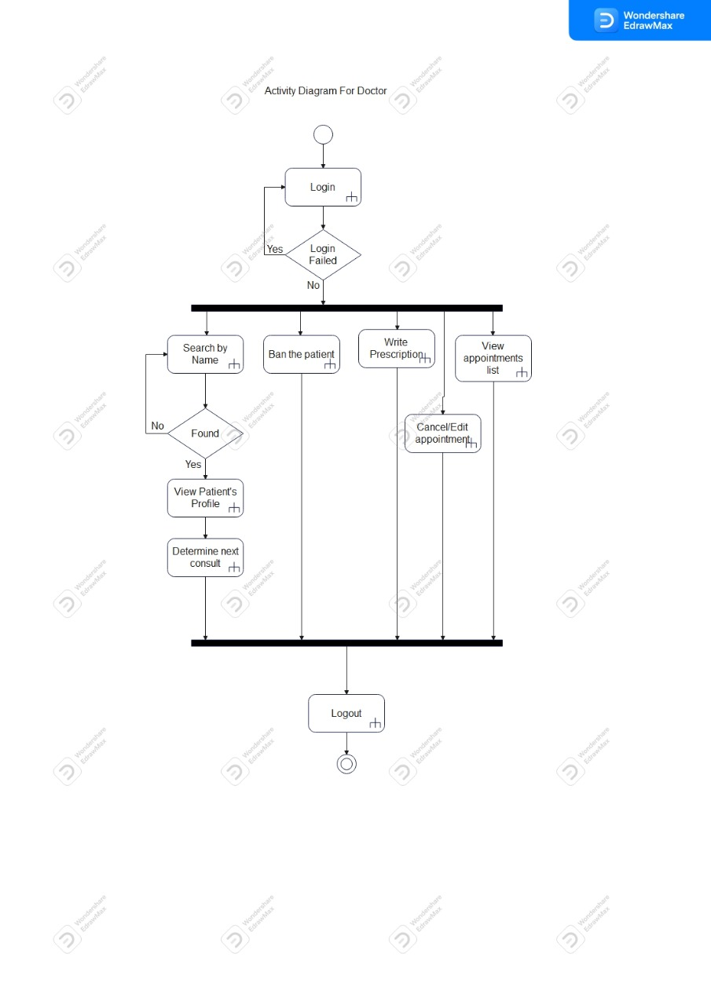

**3-Sequance Diagram:**

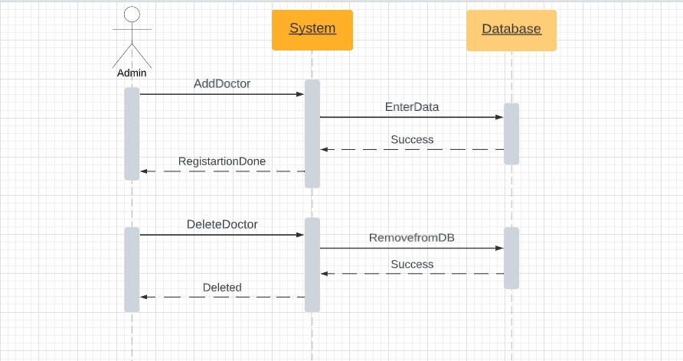

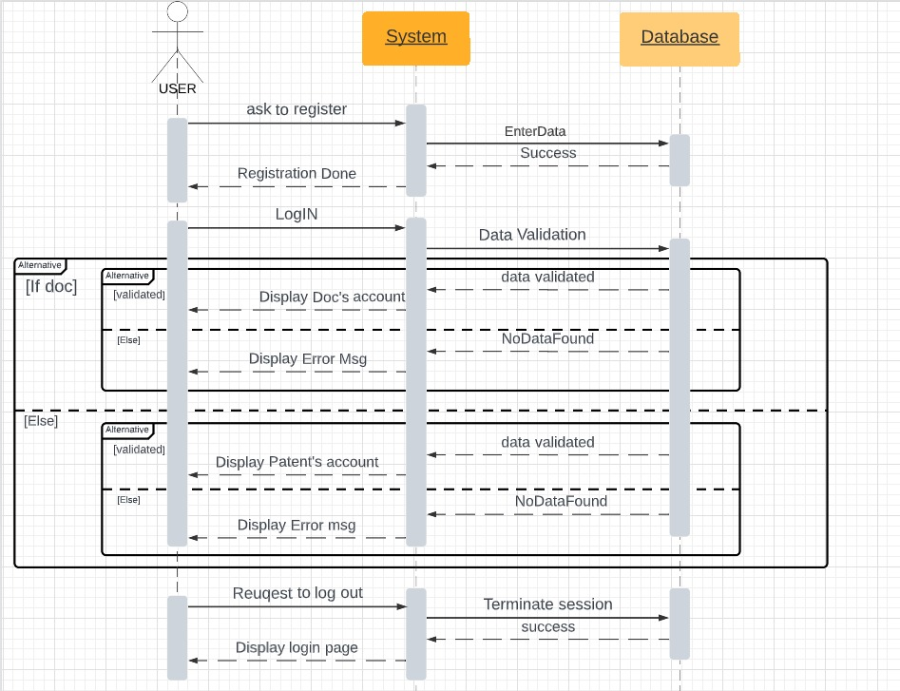

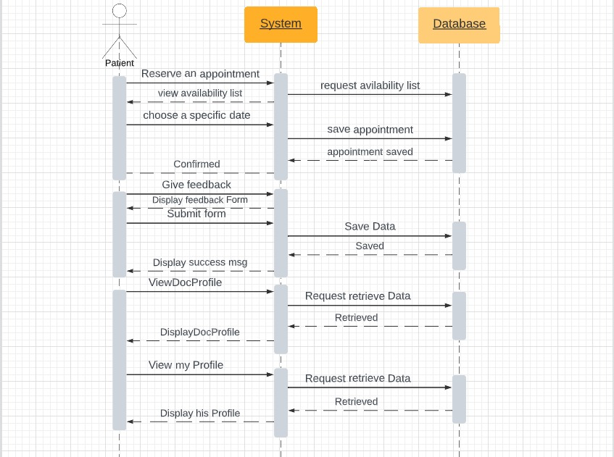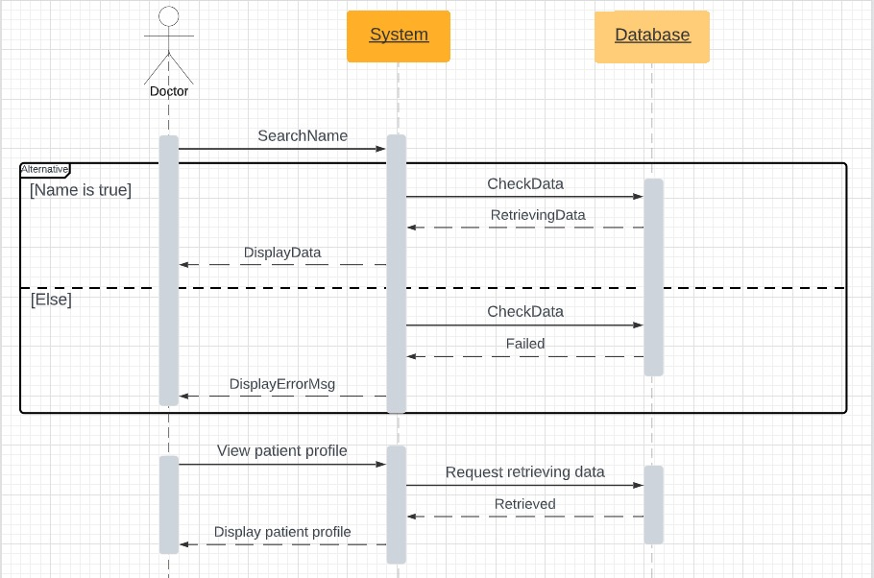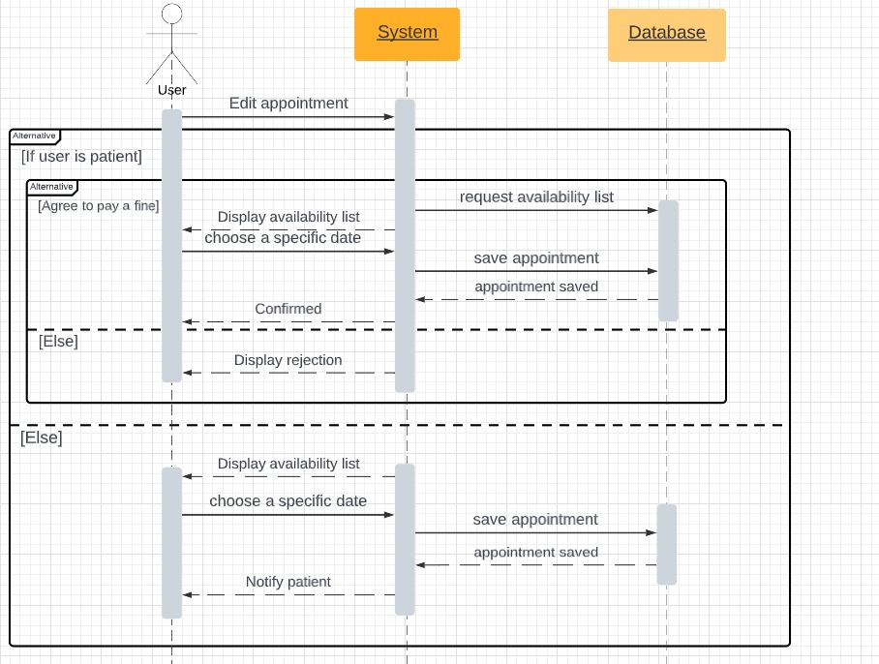

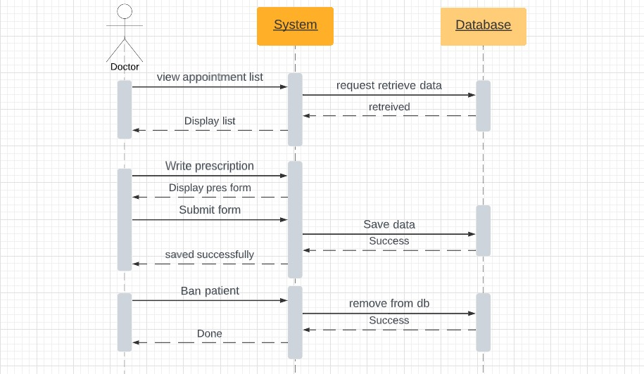

**3-Class Diagram:**

